HOME AUTOMATION - ASSIGNMENT 1

Components Used :

Arduino

PIR Sensor

Gas Sensor

LDR

Temperature Sensor

Motors

Leds

L293D -> Motor Driver

Buzzer

Code :

const int temperature = A3;

const int pirSignal = 10;

const int irSignal = 3;

const int gasSensor = A5;

const int motorOutput1 = 4;

const int motorOutput2 = 5;

const int motorEnable = 9;

const int ledPin = 6;

const int doorLed = 8;

const int ldrSignal = A0;

const int lightOn = 11;

void setup()

{

Serial.begin(9600);

pinMode(temperature, INPUT);

pinMode(pirSignal, INPUT);

pinMode(irSignal, INPUT);

pinMode(gasSensor, INPUT);

pinMode(motorOutput1, OUTPUT);

pinMode(motorOutput2, OUTPUT);

pinMode(motorEnable, OUTPUT);

pinMode(doorLed, OUTPUT);

pinMode(ledPin, OUTPUT);

pinMode(lightOn, OUTPUT);

digitalWrite(motorOutput1,HIGH);

digitalWrite(motorOutput2,LOW);

}

void loop()

{

// Automatic fan On/Off

int reading = analogRead(temperature);

float voltage = reading \* (5.0 / 1024.0);

float temp = voltage \* 100;

if(temp >= 83.0)

{

int fanSpeed = map(temp,83.01,174.0,100,255);

Serial.println(fanSpeed);

Serial.println(temp);

analogWrite(motorEnable,fanSpeed);

}

else

{

analogWrite(motorEnable,0);

}

// Alerting for gas leakage

int gasReading = analogRead(gasSensor);

if (gasReading > 90)

{

digitalWrite(ledPin,HIGH);

}

else

{

digitalWrite(ledPin,LOW);

}

// Automatic Door Open

int pir = digitalRead(pirSignal);

Serial.println(gasReading);

if (pir == 1)

{

digitalWrite(doorLed,HIGH);

}

else

{

digitalWrite(doorLed,LOW);

}

// Automatic Light On

int ldrReading = analogRead(ldrSignal);

if (ldrReading < 526)

digitalWrite(lightOn,HIGH);

else

digitalWrite(lightOn,LOW);

delay(1000);

}

Circuit Diagram :

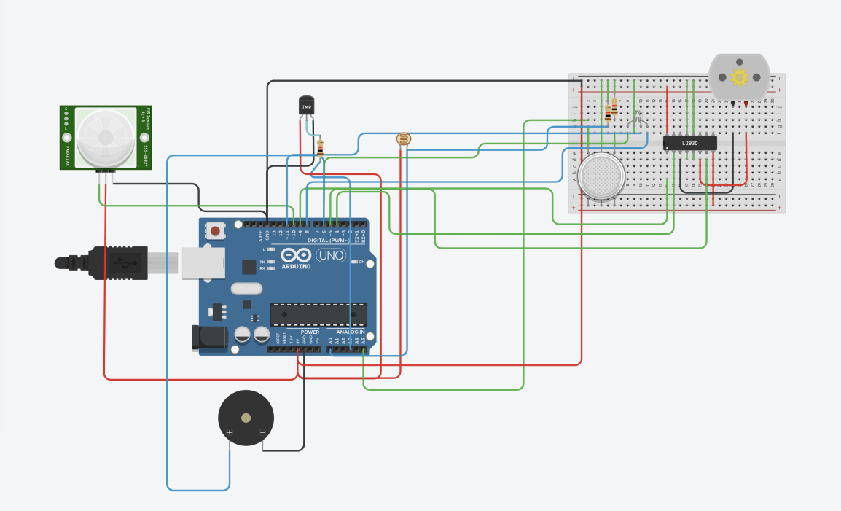

Submitted By

VIGNESH S

7376191EC309